**Tableau Goals**

**Goal 1:**

**Goal 2:**

**Goal 3:**

**Goal 4:**

**Goal 5:**

**Goal 6:**

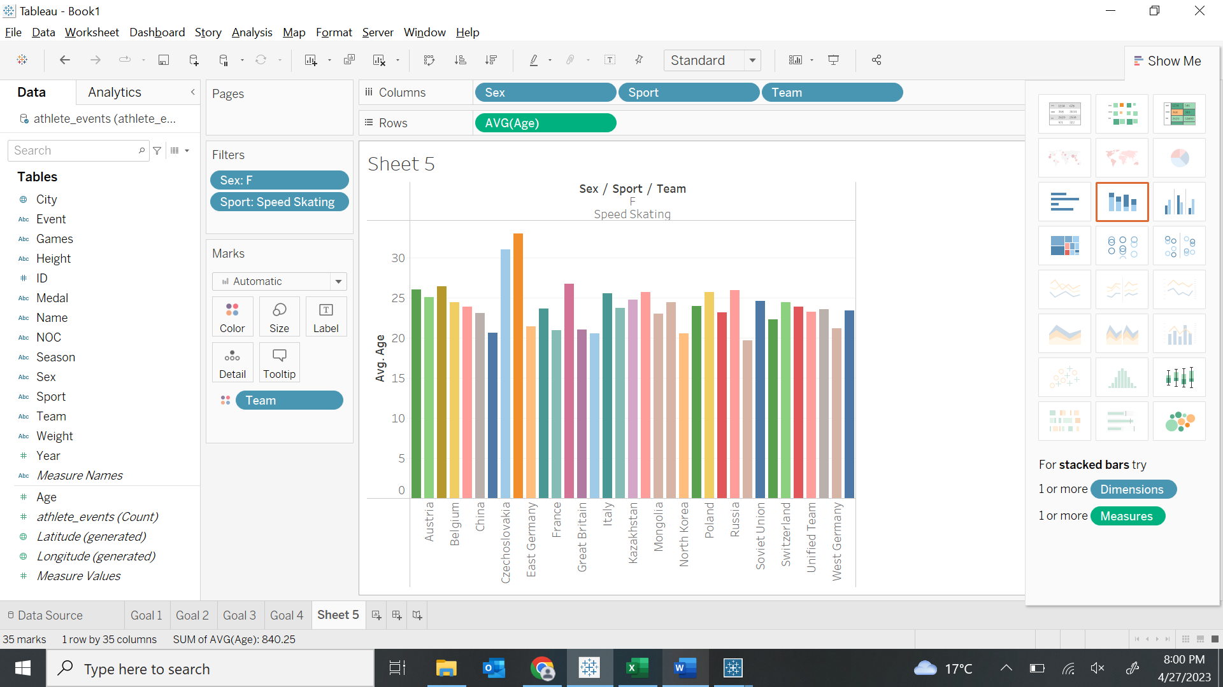

**Goal 7**

**Goal 8:**

**Goal 9:**

**Goal 10:**

